Cosmetics Insights Analysis:
An Interactive Tableau Dashboard for Beauty & Skincare Business Intelligence

Team ID:
Author: Mohit Mamgain
Domain: Data Analytics & Business Intelligence
College: Manav Rachna International Institute of Research and Technology

PROJECT FINAL REPORT
Date: 14 July 2026

1. Introduction

1.1 Project Overview
The cosmetics and skincare market now spans hundreds of brands, thousands of individual products, and a wide range of prices, categories, and skin-type formulations. For brand managers, e-commerce merchandisers, and marketing teams, understanding how pricing varies across brands, which categories generate the most revenue, and which products suit which skin types is central to good assortment, pricing, and campaign decisions.
This project, “Cosmetics Insights Analysis,” examines a cosmetics product dataset covering brand, product name, category, ingredients, price, popularity rank, and skin-type suitability (combination, dry, normal, oily, sensitive). It takes a raw, unclean dataset and turns it into a clean, interactive Tableau dashboard built around the KPIs and comparisons that matter most to people working in beauty retail and marketing.
Using KPI cards, brand and category breakdowns, and a price-vs-rank comparison, brand managers, retailers, and marketers can quickly see which brands price high or low, which categories drive the most revenue, and how products are distributed across skin types. The dashboard is also embedded in a lightweight Flask web application, so the analysis can be shared as a portfolio piece with a shareable link rather than a static export.

1.2 Purpose
The purpose of the “Cosmetics Insights Analysis” project is to give a clear, KPI-based view of how cosmetics brands and products compare on price, category, and skin-type suitability. The project aims to:
- Help brand managers and retailers understand how brands compare on average pricing.
- Identify which product categories (Cleanser, Eye Cream, Sun Protect, Moisturizer, Treatment, Face Mask) generate the most revenue.
- Show which brands carry the largest product ranges, by count.
- Examine the relationship between product price and popularity rank.
- Break down category-wise distribution specifically for combination-skin products, the most commonly searched skin-type segment.
- Give marketing and merchandising teams a single, filterable dashboard to base pricing and assortment decisions on, instead of scanning raw spreadsheets.
In short, the project gives stakeholders a practical tool for reading brand pricing behaviour, category performance, and skin-type coverage, grounded in the data itself rather than assumption.

2. Ideation Phase

2.1 Problem Statement
Customer Problem Statement Template:
A clear problem statement keeps the project anchored to what the end user actually needs. For this project, that means the day-to-day struggle brand managers, retailers, and marketing teams face when trying to read brand pricing, category revenue, and skin-type coverage out of raw, unclean product data. The analysis covers cosmetics products alongside brand, category, price, rank, and skin-type suitability, with an interactive dashboard that lets users filter and compare directly — informing pricing, assortment, and marketing decisions.
I AM | I'M TRYING TO | BUT | BECAUSE | WHICH MAKES ME FEEL
A brand manager, retail merchandiser, or marketing team member looking to understand cosmetics pricing and product performance. | Compare brand pricing, identify top categories by revenue, and target the right skin-type segments using an interactive Tableau dashboard. | I struggle to interpret raw cosmetics data with missing values and inconsistent brand, category, and skin-type labels. | Cosmetics product data is scattered across brands and categories, and spreadsheets do not offer interactive, filterable KPI views, making comparison slow. | Confused and uncertain about pricing and assortment decisions — risking mispriced products and missed skin-type coverage.

Customer Problem Summary
What brand managers and marketers need is a simple, interactive way to explore cosmetics product data and see what actually drives pricing, category revenue, and skin-type coverage — so they can make confident, data-driven decisions on pricing and assortment.
Impact
- Poor Pricing Decisions — brands priced out of line with the market.
- Revenue Loss — missed opportunities in high-revenue categories.
- Time Consuming — manual analysis of raw, unclean product data.
- Missed Skin-Type Coverage — gaps in combination, dry, oily, or sensitive-skin ranges.

Problem Statement (PS-1)
I am (Customer) | I'm trying to | But | Because | Which makes me feel
A brand manager or marketing analyst looking to understand cosmetics pricing and category performance. | Analyse brand pricing, category revenue, and skin-type coverage using an interactive Tableau dashboard. | I struggle with raw, unclean data (missing values, inconsistent brand and category names) and cannot identify meaningful KPIs quickly. | Static spreadsheets do not provide interactive visual comparisons, making brand and category analysis slow and error-prone. | Confused and uncertain — risking mispriced products and poor category focus.

2.2 Empathy Map Canvas
An empathy map lays out what's known about a user's behaviour and attitudes in one place. Here, it helps brand managers and marketers read cosmetics pricing and category trends and see which brands and categories are actually driving performance.
Before building the dashboard, it helps to step into the shoes of the person who'll actually use it — what they're trying to get done, and where they keep getting stuck. That's what the map below sets out.
SAYS | THINKS | DOES | FEELS
“Which brand is priced highest in this category?” “Why does this brand have so few products?” “Which category earns the most revenue?” | Wants a single dashboard with clear KPIs. Believes visual data will reveal pricing gaps. Worries about mispricing new launches. | Checks brand and category reports regularly. Reviews price-vs-rank trends. Plans marketing by skin type. Tries to clean data in Excel. | Overwhelmed by raw, messy data. Frustrated by inconsistent labels. Confident when KPIs are clear and actionable.

PAIN — Unclean data, no unified view, difficulty comparing brands, low pricing-decision confidence.
GAIN — Clear KPIs, interactive brand/category filters, price-vs-rank comparison, better assortment and marketing focus.

2.3 Brainstorming
Step-1: Problem Selection
Several ideas in the beauty-retail space were considered (ingredient-safety scoring, review sentiment analysis, price-comparison tools). “Cosmetics Insights Analysis” was chosen because it addresses a real, everyday need for brand managers and analysts, and fits well within the available dataset and Tableau scope.
Step-2: Idea Listing and Grouping
Ideas were grouped into three buckets:
- Business KPIs: Total Products, Total Brands, Skin-Type Coverage.
- Brand & Category Analysis: Brand pricing, brand product counts, category-wise revenue, price vs. rank.
- Skin-Type Analysis: Category-wise distribution of products for each skin type, starting with combination skin.
Step-3: Idea Prioritization
Idea | Feasibility | Impact | Priority
KPI cards (Total Products, Brands, Skin Types) | High | High | P1
Brands with Average Pricing chart | High | High | P1
Category Level Product Distribution | High | High | P1
Top 10 Brands by Product Count | High | High | P1
Category-wise Total Revenue | High | High | P1
Price vs Rank Scatter Plot | High | Medium | P2
Category-wise distribution for combination skin | High | Medium | P2
Predictive pricing model (ML) | Medium | Medium | P3 (future scope)

3. Requirement Analysis

3.1 Customer Journey Map
The customer journey map below shows the end-to-end experience of a brand manager or analyst using the Cosmetics Insights Dashboard — from data collection to actionable insight.
Stage | User Action | Touchpoint | Emotion
Awareness | Realizes raw cosmetics data is hard to compare across brands | Excel / CSV | Frustrated
Data Collection | Downloads Cosmetics product dataset | Kaggle / GitHub | Hopeful
Preparation | Cleans nulls, standardizes brand / category / skin-type values | Excel / Tableau Prep | Focused
Visualization | Builds KPI cards, brand and category charts in Tableau | Tableau Public | Engaged
Insight | Identifies top brands, top categories, price-rank patterns | Dashboard | Confident
Action | Uses insights for pricing, assortment, and marketing decisions | Business Ops | Satisfied

3.2 Solution Requirements
FR No. | Functional Requirement | Sub-Requirement (Story / Task)
FR-1 | Data Collection | Download Cosmetics product dataset (CSV).
FR-2 | Data Cleaning | Handle nulls, remove duplicates, standardize brand / category / skin-type values, fix data types.
FR-3 | Calculated Fields | Create Revenue, Skin-Type Count, and Category grouping calculated fields.
FR-4 | KPI Cards | Total Products, Total Brands, Skin Types Count.
FR-5 | Visualizations | Brands with Average Pricing, Category Level Product Distribution, Category-wise Total Revenue, Top 10 Brands by Product Count, Price vs Rank Scatter Plot.
FR-6 | Interactive Dashboard | Brand filters, tooltips, legend-based category filtering.
FR-7 | Publishing | Publish workbook on Tableau Public with a shareable link.
FR-8 | Web Integration | Embed dashboard in a Flask web app (index.html, style.css, main.js) for portfolio sharing.

Non-Functional Requirements
NFR No. | Non-Functional Requirement | Description
NFR-1 | Usability | Dashboard must be intuitive with clear labels, tooltips and a consistent colour theme.
NFR-2 | Performance | Dashboard should load within 5 seconds on Tableau Public.
NFR-3 | Reliability | All KPIs and charts must reflect the cleaned dataset accurately.
NFR-4 | Scalability | Design should support additional brands / categories without redesign.
NFR-5 | Availability | Published Tableau Public link and Flask web app must be publicly accessible 24×7.

3.3 Data Flow Diagram
Data Flow — Level 1 (Project Overview)
The flow below describes how raw cosmetics product data moves through cleaning, transformation, visualization, and finally to the end user via the Tableau dashboard and its Flask-embedded web view.
# | Process | Description
1 | Data Source | Raw cosmetics product CSV file (brand, product, category, price, rank, ingredients, skin type).
2 | Data Cleaning | Nulls handled, duplicates removed, brand / category / skin-type names standardized.
3 | Data Transformation | Calculated fields (Revenue, Skin-Type Count, Category grouping) created.
4 | Data Visualization | Cleaned data connected to Tableau; KPI cards and charts built.
5 | Dashboard Assembly | Charts assembled into a single interactive Tableau dashboard.
6 | Web Embedding | Dashboard published to Tableau Public and embedded in a Flask web app.
7 | User Interaction | End users filter by brand/category and derive insights from the published dashboard.

3.4 Technology Stack
The build is deliberately lightweight: raw data is cleaned and transformed, visualized in Tableau, published on Tableau Public, and embedded into a small Flask web application for portfolio presentation.
S.No | Component | Description | Technology
1 | Data Source | Cosmetics product dataset (CSV) | Kaggle / GitHub
2 | Data Cleaning | Handle nulls, standardize categorical values | Excel, Tableau Prep
3 | Data Storage | Cleaned .csv / .hyper extract file | Local file system / GitHub
4 | Visualization Engine | KPI cards, brand & category charts, dashboard | Tableau Public 2024.x
5 | Web Integration | Embeds the published dashboard in a portfolio site | Python, Flask, HTML5, CSS3, JavaScript
6 | Publishing | Public web-hosted interactive dashboard | Tableau Public Cloud
7 | Version Control | Source code, dataset, screenshots, workbook (.twbx) | Git & GitHub

4. Project Design

4.1 Problem-Solution Fit
The Problem-Solution Fit canvas below ensures the proposed dashboard truly solves real problems faced by brand managers, retailers, and marketing teams.
Block | Details
1. Customer Segment(s) | Brand managers, cosmetics retailers, marketing teams, and beauty e-commerce analysts.
2. Jobs-to-be-Done / Problems | Compare brand pricing, identify top-revenue categories, and target the right skin-type segments.
3. Triggers | Uneven pricing across brands, unclear category performance, unclear skin-type coverage.
4. Emotions Before / After | Before: confused, overwhelmed by raw data. After: confident, empowered by clear KPIs.
5. Available Solutions | Static spreadsheet reports, generic BI tools without a beauty-domain focus, expensive custom dashboards.
6. Customer Constraints | Limited time, limited data-cleaning skills, small analytics budget.
7. Behaviour | Users check pricing and category reports periodically, but rely on gut feel over data.
8. Channels of Behaviour | Online: Tableau Public link and portfolio website. Offline: printed reports in pricing meetings.
9. Problem Root Cause | Raw cosmetics data is messy, scattered and non-visual, making brand and category comparison slow.
10. Your Solution | A cleaned dataset plus an interactive Tableau dashboard, embedded in a portfolio web app, presenting all key KPIs and comparisons in one view.

4.2 Proposed Solution
S.No | Parameter | Description
1 | Problem Statement | Brand managers and analysts cannot easily interpret raw cosmetics data to identify pricing, category, and skin-type trends.
2 | Idea / Solution | Build an interactive Tableau dashboard on cleaned cosmetics product data with KPI cards, brand pricing charts, and category breakdowns.
3 | Novelty / Uniqueness | Combines brand pricing, category revenue, and skin-type analysis in one Tableau Public workbook, embedded in a branded Flask portfolio site.
4 | Social Impact / Customer Satisfaction | Better pricing and category focus support fairer assortment planning and more relevant skin-type targeting.
5 | Business Model / Revenue Model | Enables brands and retailers to boost revenue via data-driven decisions on pricing and category mix.
6 | Scalability | Easily extendable to more brands, categories, or additional datasets without changing the architecture.

4.3 Solution Architecture
Five layers take the data from raw file to finished, shareable insight:
Layer | Responsibility | Technology
1. Source Layer | Raw dataset ingestion | Kaggle CSV / GitHub
2. Preparation Layer | Cleaning, standardization, calculated fields | Excel / Tableau Prep
3. Storage Layer | Cleaned .csv / .hyper extract | Local / GitHub
4. Visualization Layer | KPI cards, brand and category charts, dashboard | Tableau Desktop / Public
5. Presentation Layer | Public shareable link, embedded portfolio site | Tableau Public Cloud, Flask

5. Project Planning & Scheduling

5.1 Project Planning
Product Backlog, Sprint Schedule and Estimation
Sprint | Functional Requirement | User Story / Task | Story Points
Sprint-1 | Data Collection | Download Cosmetics product dataset. | 2
Sprint-1 | Data Cleaning | Handle nulls, standardize brand / category / skin-type values. | 5
Sprint-1 | Calculated Fields | Create Revenue and Skin-Type Count calculated fields. | 3
Sprint-1 | Data Import | Connect cleaned dataset to Tableau Public. | 2
Sprint-1 | Setup Repository | Create GitHub repo with structure and README. | 2
Sprint-2 | KPI Cards | Build KPI cards (Total Products, Total Brands, Skin Types Count). | 4
Sprint-2 | Charts | Build Brands with Average Pricing, Category Distribution, Top 10 Brands charts. | 6
Sprint-2 | Dashboard | Assemble interactive dashboard with filters and tooltips. | 4
Sprint-2 | Web Embed & Publish | Publish workbook, build Flask embed site, prepare demo. | 6

Sprint Duration & Velocity
Sprint | Total Story Points | Duration | Start Date
Sprint-1 | 14 | 6 Days | 01 Jul 2026
Sprint-2 | 20 | 6 Days | 07 Jul 2026

Velocity Calculation:
Velocity = Total Story Points Completed / Number of Sprints
Total Story Points = 14 + 20 = 34
Number of Sprints = 2
Velocity = 34 / 2 = 17 Story Points per Sprint

6. Functional and Performance Testing

6.1 Performance Testing
The dashboard was tested for functionality, correctness of KPIs, filter interactivity, load performance, and cross-browser access on Tableau Public and the Flask-embedded web view.
Test ID | Test Case | Expected Result | Status
T-01 | KPI cards display Total Products, Total Brands, Skin Types Count | All 3 KPIs visible with correct values | Pass
T-02 | Brand filter | Charts update based on selected brand | Pass
T-03 | Category legend filter | Charts update based on selected category | Pass
T-04 | Tooltips | Tooltips show correct metric values on hover | Pass
T-05 | Dashboard load time | Loaded in under 5 seconds on Tableau Public | Pass
T-06 | Cross-browser | Works on Chrome, Edge and Firefox | Pass
T-07 | Mobile responsiveness | Dashboard viewable on tablet and phone | Pass
T-08 | Flask web embed | Dashboard renders correctly inside the portfolio site | Pass
T-09 | Data accuracy vs source | KPI values match cleaned dataset totals | Pass

7. Results
7.1 Output Screenshots
The following screenshots present the KPI cards, the individual chart visualizations, and the final integrated dashboard built in Tableau Public.

Full Interactive Dashboard
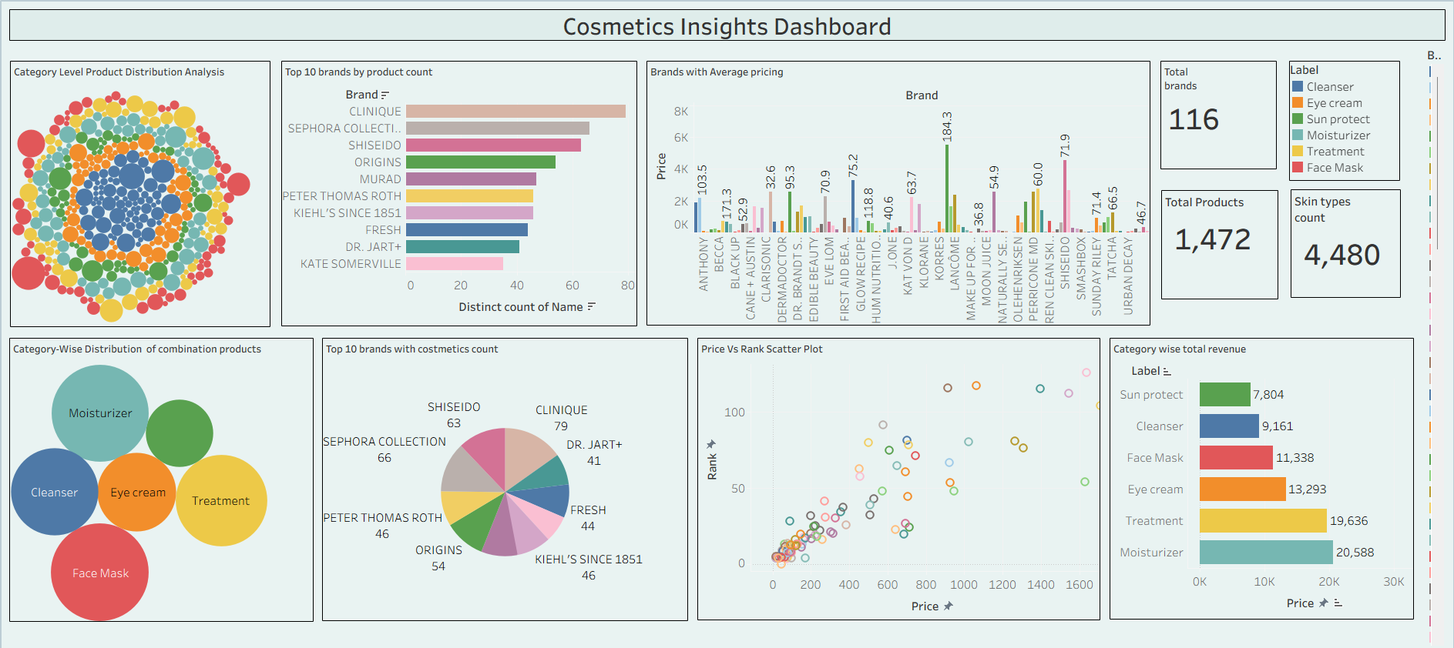
Figure 1 — Cosmetics Insights Dashboard (Tableau Public)
The dashboard brings together six views — category-level product distribution, top brands by product count, brand pricing, category-wise skin-type distribution for combination skin, brand/category counts, and a price-vs-rank scatter plot — alongside three KPI cards: Total Brands (116), Total Products (1,472), and Skin Types Count (4,480).

KPI Cards
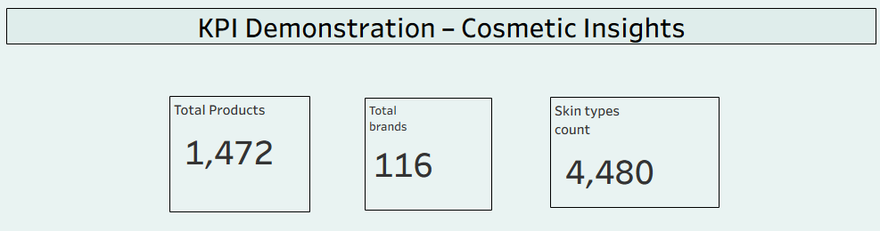
Figure 2 — Total Products, Total Brands & Skin Types Count KPI
These three headline metrics anchor the dashboard: the total number of distinct cosmetics products in the cleaned dataset (1,472), the number of distinct brands represented (116), and the total count of skin-type tags assigned across all products (4,480 — products can be suited to more than one skin type).

Brand Pricing
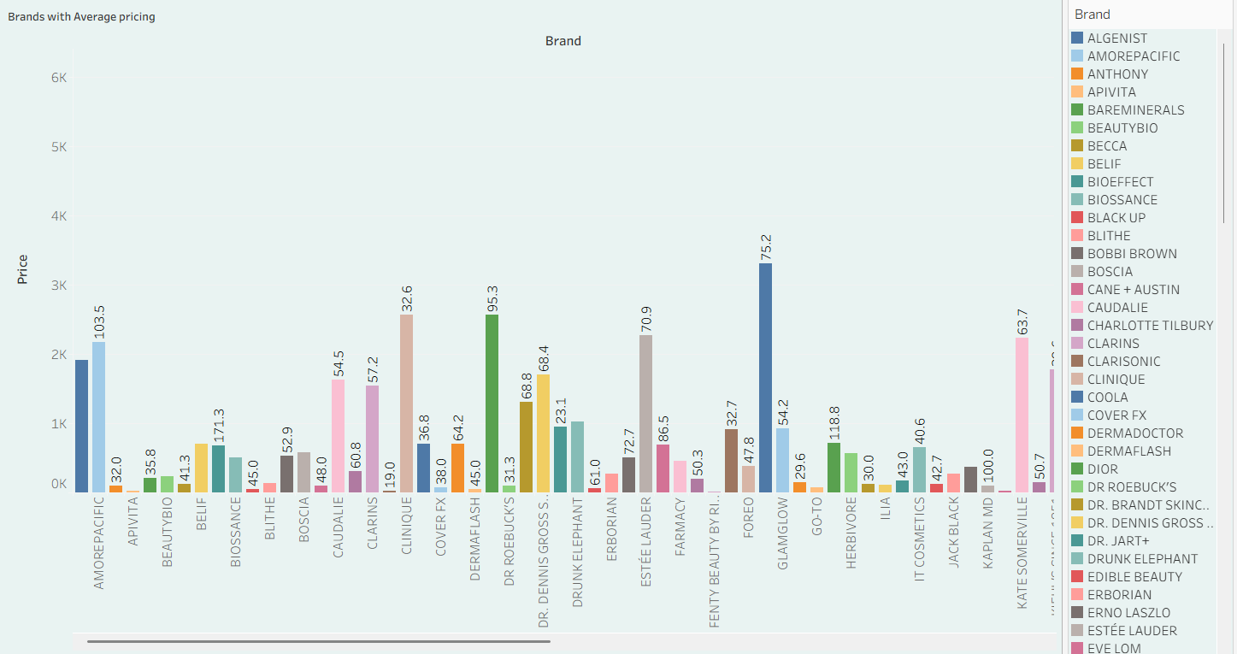
Figure 3 — Brands with Average Pricing
This chart compares average product price across every brand in the dataset. Prices range widely — from budget-friendly brands averaging under ₹20, to premium brands such as AmorePacific (₹103.5) and GlamGlow (₹75.2) sitting well above the field — giving a quick read on where each brand sits on the price spectrum.

Brand Product Counts
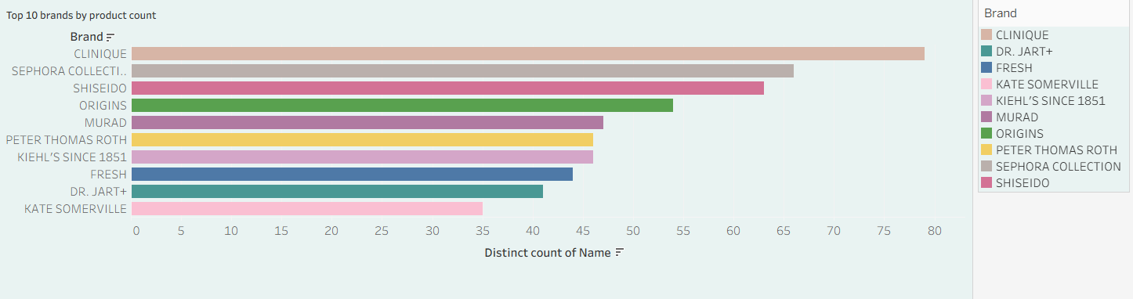
Figure 4 — Top 10 Brands by Product Count
Clinique leads the catalogue with the largest number of distinct products (~79), followed by Sephora Collection (~66) and Shiseido (~63). This view highlights which brands carry the broadest assortments in the dataset, which is useful for gauging market presence independent of price.

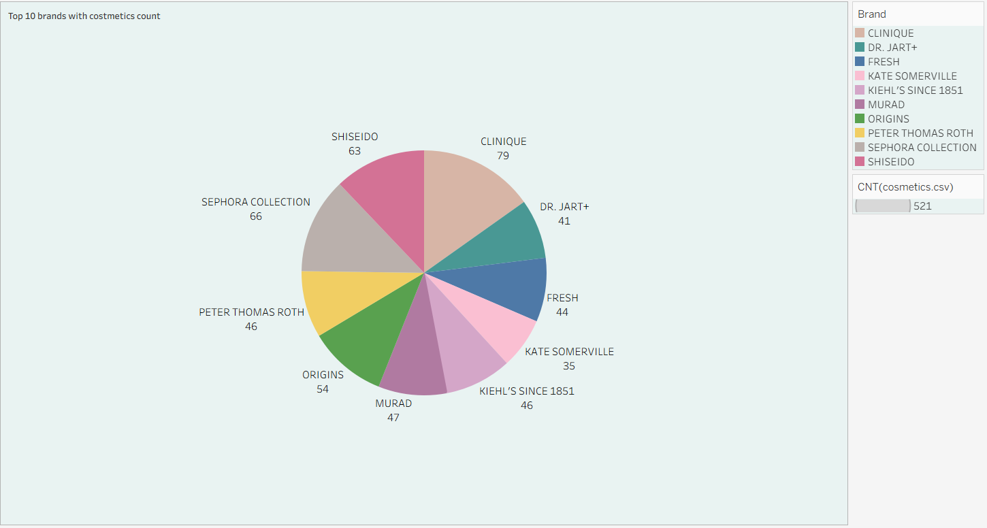
Figure 5 — Top 10 Brands with Cosmetics Count
The same top-10 brands shown as a proportional breakdown: Clinique 79, Sephora Collection 66, Shiseido 63, Origins 54, Murad 47, Kiehl’s Since 1851 46, Peter Thomas Roth 46, Fresh 44, Dr. Jart+ 41, and Kate Somerville 35, totalling 521 products across the top 10 brands alone.

Category Distribution
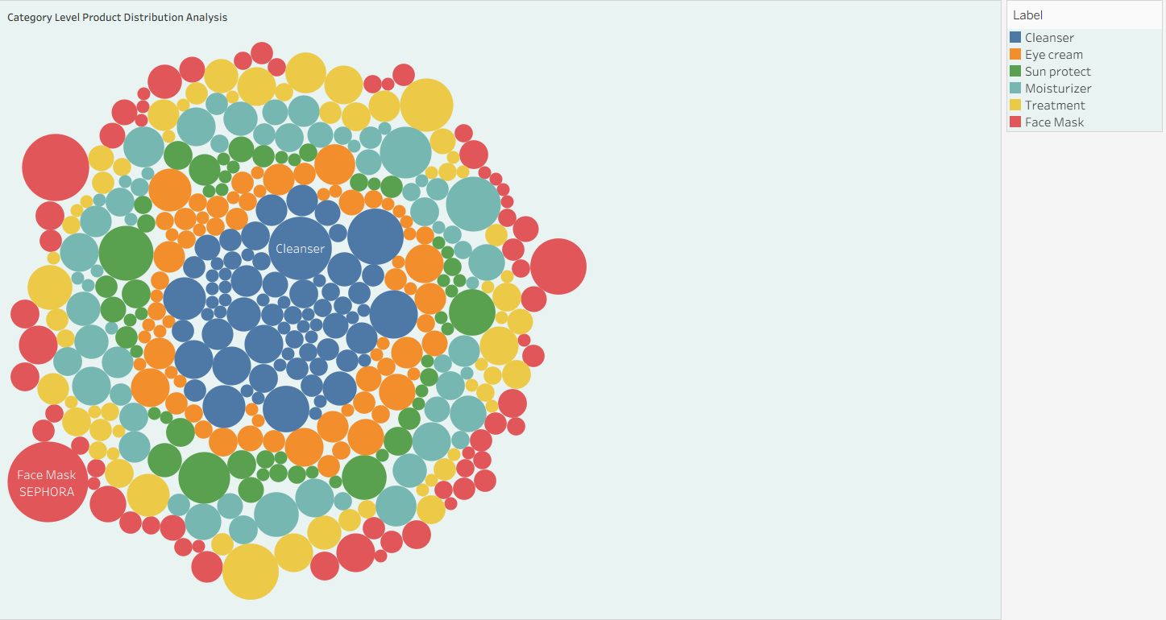
Figure 6 — Category Level Product Distribution Analysis
A packed-bubble view of every product in the dataset, sized and coloured by category (Cleanser, Eye Cream, Sun Protect, Moisturizer, Treatment, Face Mask). Cleanser and Face Mask form some of the largest individual bubbles, reflecting high-volume listings from brands like Sephora Collection.

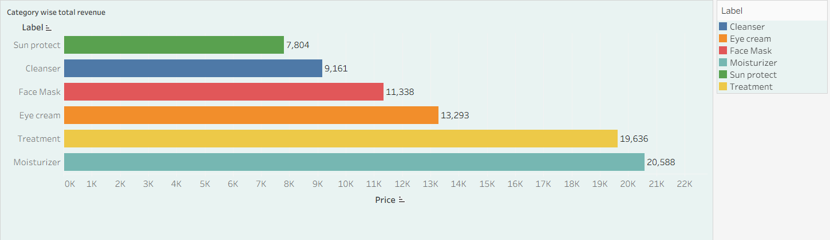
Figure 7 — Category-Wise Total Revenue
Moisturizer (₹20,588) and Treatment (₹19,636) generate the most revenue of any category, ahead of Eye Cream (₹13,293), Face Mask (₹11,338), Cleanser (₹9,161), and Sun Protect (₹7,804) — a useful signal for where to focus new product development and marketing spend.
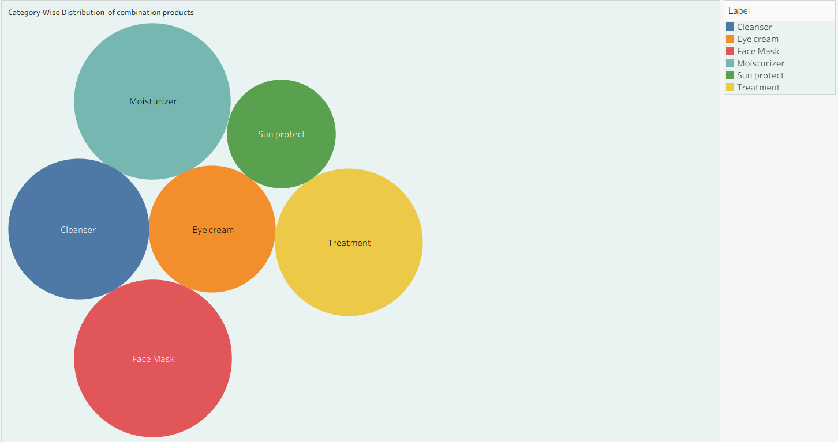
Figure 8 — Category-Wise Distribution of Combination-Skin Products
Focusing on combination skin — one of the most commonly searched skin types — this view breaks down how products for this segment are distributed across Moisturizer, Sun Protect, Cleanser, Eye Cream, Treatment, and Face Mask categories, with Moisturizer and Face Mask forming the largest shares.

Price vs Rank
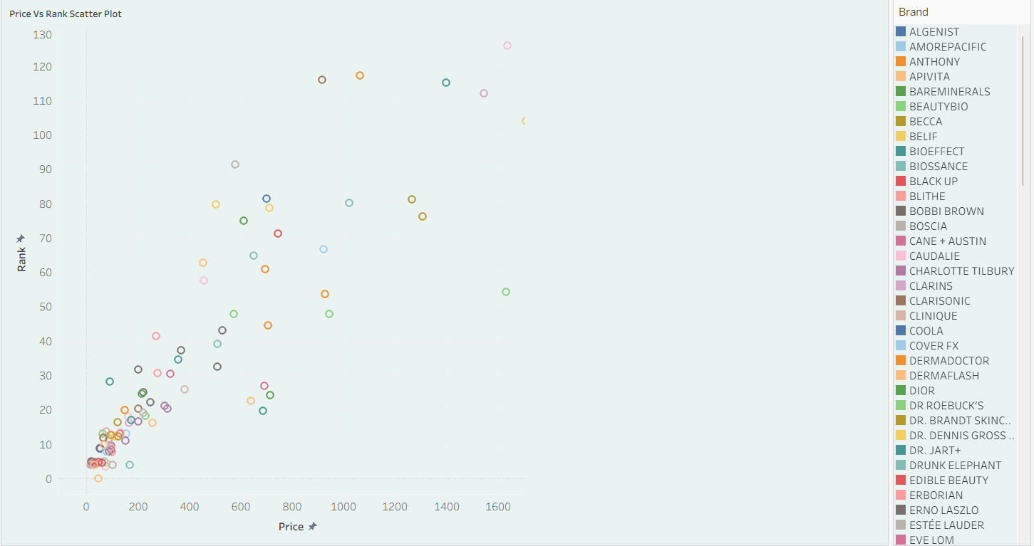
Figure 9 — Price vs Rank Scatter Plot
Plotting price against popularity rank for every product shows a broadly positive relationship — higher-priced products tend to carry a higher rank — though a cluster of low-priced, low-rank products in the bottom-left corner points to a large budget segment with more modest visibility.

8. Advantages & Disadvantages
Advantages
- Provides a single, interactive view of all critical cosmetics pricing and category KPIs.
- Helps brand managers and retailers identify high- and low-priced brands quickly.
- Highlights top-performing categories by revenue and by product count.
- Supports marketing teams in targeting the right skin-type segments.
- Free, publicly shareable, and embedded in a branded portfolio web app.
- Scalable to additional brands, categories, or datasets without redesign.
- Improves pricing and assortment decision confidence by replacing gut feel with data.
Disadvantages
- Depends on the quality and completeness of the source dataset.
- Tableau Public makes the workbook and data publicly visible — not suitable for confidential pricing data.
- Static dataset only — no real-time integration with live catalogue or pricing systems in this version.
- Predictive analytics (e.g. price or rank forecasting) is not included in this scope.
- Mobile experience, while functional, is not fully optimized for small screens.

9. Conclusion
This project took a raw, unclean cosmetics product dataset and turned it into a structured Tableau dashboard, embedded in a lightweight Flask web app. Three KPI cards and a set of brand and category charts now give a single view of pricing, product counts, category revenue, and skin-type coverage.
Brand managers, retailers, and marketing teams can use it to move faster — spotting high- and low-priced brands, identifying top-revenue categories, and targeting the right skin-type segments — without waiting on a manual report. Careful data cleaning, a small set of purpose-built calculated fields, and a dashboard layout that doesn't need much explaining are what make that possible.

10. Future Scope
- Integrate live catalogue or pricing feeds via API for near real-time KPI monitoring.
- Add a predictive layer (price positioning, rank forecasting) using Python / ML.
- Include ingredient-level analysis to flag common actives across categories.
- Expand skin-type breakdowns to dry, oily, normal, and sensitive skin, alongside combination.
- Add a brand-login layer with role-based views (brand manager vs retailer vs marketer).
- Deliver automated pricing-alert reports to stakeholders via email.

11. Appendix
Source Code
All source files (Tableau workbook .twbx, cleaned dataset, screenshots, Flask web app, README) are maintained in the GitHub repository listed below.
Dataset
Cosmetics Product Dataset — brand, product name, category, ingredients, price, rank, and skin-type suitability (combination, dry, normal, oily, sensitive).
Links
GitHub Repository: https://github.com/Mohitmamgain01/Cosmetic-Insights-Analysis
Tableau Public Profile: https://public.tableau.com/app/profile/mohit.mamgain6376/vizzes

Project Details
Author: Mohit Mamgain
Domain: Data Analytics & Business Intelligence
Tool: Tableau Public 2024.x
Web Stack: Python, Flask, HTML5, CSS3, JavaScript

